Title of the Abstract [Calibri, Font Size 14, Line Space 1, Bold, Centerd]

INITIALS Surname*¹, INITIALS Surname² and INITIALS Surname³ [Calibri, font size 12, line space 1, bold, centerd]
¹Affiliation of First Author (Eg. Department, Institute/University), ²affiliation of Second Author, ³Affiliation of Third Author [Calibri, Font size 11, line space 1, centerd]
*author@abc.com [Corresponding author - email: Calibri, font size 10, line space 1, Italic, centerd]

Introduction [Font calibri, 11 points, regular, line space 1, justify]
<<Write your Introduction here>>

Research Problem/s, Objective/s [Font calibri, 11 points, regular, line space 1, justify]
<<Write your Research Problem/s, Objective/s here>>

Materials and Methods [Font calibri, 11 points, regular, line space 1, justify]
<<Write your Materials and Methods here>>

Results and Discussion [Font calibri, 11 points, regular, line space 1, justify]
<<Write your Results and Discussion here>>

Table1. Tables should be clear and legible. Each table should have a brief title, which should appear at the top of the table with the table number. [Font calibri, 11 points, regular, line space 1, centerd]

Your Text | Your Text
 | Your Text | Your Text | Your Text | Your Text | Your Text
Your Text | Your Text | Your Text | Your Text | Your Text | Your Text
Your Text | Your Text | Your Text | Your Text | Your Text | Your Text
Your Text | Your Text | Your Text | Your Text | Your Text | Your Text
Your Text | Your Text | Your Text | Your Text | Your Text | Your Text

All graphical illustrations, flow charts, line drawings etc. are considered as figures. Number and the title of the figures should be indicated below them.

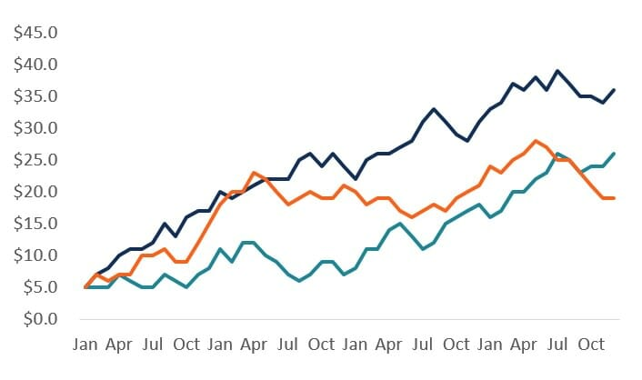
Figure 1. Each figure should carry a brief title. This should appear at the bottom of the figure with the figure number. [Font calibri, 11 points, regular, line space 1, centerd]

Conclusions and Recommendations [Font calibri, 11 points, regular, line space 1, justify]
<<Write your Conclusions and Recommendations here>>

Keywords: Maximum 5 keywords separated by commas [Font calibri, 11 points, regular, line space 1, regular, justify]

References [Use APA 7 Referencing Stsle, Maximum 5 References, Font Calibri, 11 Points, Regular, Line Space 1, Right Intend, justify]
Barnet, S., Bellanca, P., & Stubbs, M. (2013). A short guide to college writing. Pearson Education.
Caron, T. (2008). Teaching writing as a con-artist: When is a writing problem not? College Teaching, 56(3), 137-139. https://doi.org/10.3200/CTCH.56.3.137-139
Cismas, S. C. (2010). Educating academic writing skills in engineering. In P. Dondon & O. Martin (Eds.), Latest trends on engineering education (pp. 225-247). WSEAS Press.

